Activity 2   
The Signature of the Stars

Rainbows reveal that white light is a combination of all the colours. In 1666, Isaac Newton showed that white light could be separated into its component colours using glass prisms. Soon scientists were using this new tool to analyze the light coming from several different light sources. Some scientists looked at hot objects and gases; others looked at the stars and planets. They all made observations and detected patterns, but it took about 250 years for scientists to understand the connections.

Part 1: Every Element Has   
a Unique Signature.

Every element emits a unique range of colours called an emission spectrum. A similar spectrum is produced when light shines through a gas; however, in this case certain colours, or wavelengths, are absorbed by the gas. An absorption spectrum is the pattern of colours and dark lines that is produced when light shines through a gas and the gas absorbs certain wavelengths. This is the same pattern that occurs in the emission spectrum for the same medium. Figure 1 shows some simplified absorption spectral lines.

Figure 1 The lines indicate the wavelengths of light that are missing from the light after passing through the sample. The weight (thickness) of the lines indicates the amount of light absorbed at that wavelength. The heavier (or thicker) the line, the more light is absorbed.



1. Scientists can use absorption spectra to   
   analyze unknown substances. Identify the   
   elements present in the sample that   
   produces the spectra in Figure 2.

Figure 2 SImplified absorption spectra

Part 2: The Light from Stars Contains Information.

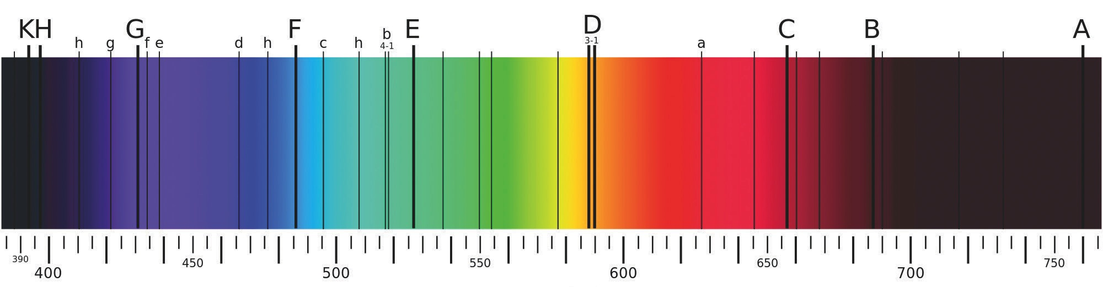The core of a star is very hot (~15 × 106 K), and very hot objects glow. The light produced by a star’s core contains all the colours in the spectrum. Astronomers can learn many things about a star’s motion, temperature, and composition by analyzing the starlight that reaches Earth. A spectroscope is an instrument that separates light into its spectrum. One of the earliest uses of the spectroscope was to analyze light coming from astronomical objects. The light directed from a telescope through a spectroscope produces an image called a **spectrograph**. Figure 3 shows a spectrograph of the Sun.

**Wavelength (nm)**

Figure 3 A spectrograph of the Sun. **Note:** The lettered lines represent different elements. Lines A and B are due to terrestrial oxygen and are not due to the Sun.

1. What do the dark lines in Figure 3 indicate?

1. Predict what happens to light as it travels from the core of the Sun to the surface?
2. Where do you think the elements in the outer layers of the Sun come from?

1. 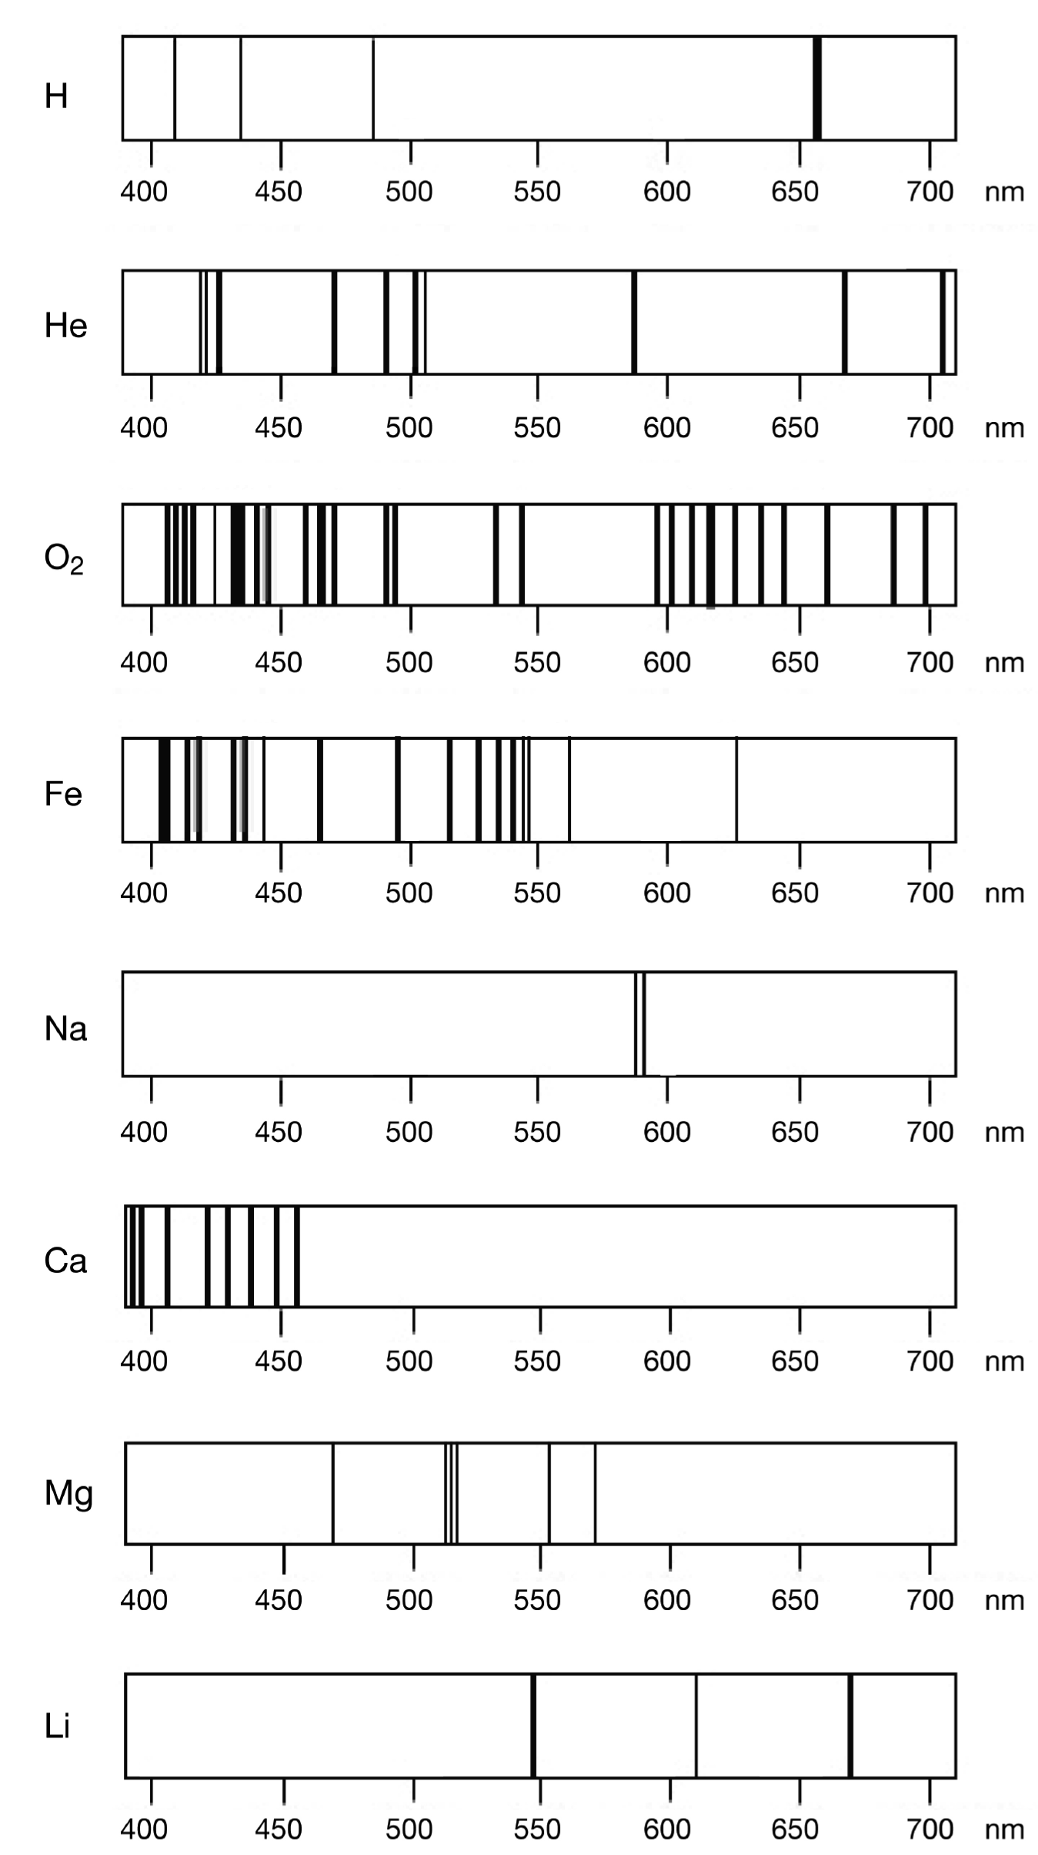Use Figure 3 and the simplified absorption spectra in Figure 4 to identify which elements are in the Sun, that is, which element each letter in Figure 3 represents (except for A and B).

Figure 4 Simplified absorption spectra

Part 3: The Spectra from Galaxies Are Redshifted.

Figure 5 Redshifted spectrum from quasar 3C 273

In 1912, American astronomer   
Vesto Slipher began to observe more distant objects using a spectrometer, and he noticed that most of them had a distinct shift toward the red end of the spectrum. He recognized this as a Doppler shift caused by the motion of the objects. A redshift means that the source of light is moving away from the observer.

Figure 5 shows an emission spectrum from the quasar called 3C 273. We see that the emission lines due to hydrogen are shifted to the red end of the spectrum. The larger the redshift, the greater the relative motion.

1. Edwin Hubble extended this observation to more objects, and for several objects plotted the redshift versus the distance to the object. Try it for yourself. In Table 1, use the redshift of the spectral lines to determine the speed of each galaxy. To do this, use a ruler to align the leftmost spectral line provided with each galaxy with the speed scale at the bottom of   
   the table.

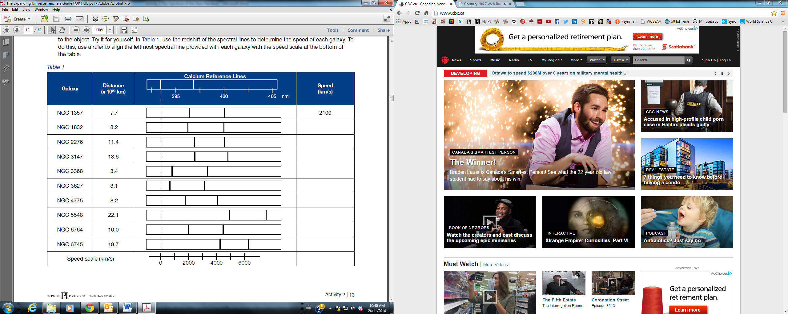

1. Plot the speed of each galaxy in Table 1 on the *x-*axis and the distance to the galaxy on the *y*-axis. Draw a line of best fit.

[](http://wiki.inkscape.org/wiki/images/CartesianGridEffect.png)

1. (a) Calculate the slope of the line. What is the unit for the slope? Note: don’t forget the "x102" in your calculation!

(b) What physical quantity has the same unit?

1. What does it tell about the relationship between the distance of galaxies and their speeds?
2. Distance is equal to speed multiplied by time. This suggests that the slope represents the time it has taken each of these galaxies to travel the indicated distance since the big bang. Convert the time found in question 8 into years using the following conversion: (ex: 4.5 x1017 / (3600x24x365) = … Then convert to billions of years. 1 billion = 1 000 000 000)

11. The known age of the universe Is 13.5 billion years. How did your value (i.e. your slope) compare to this age?

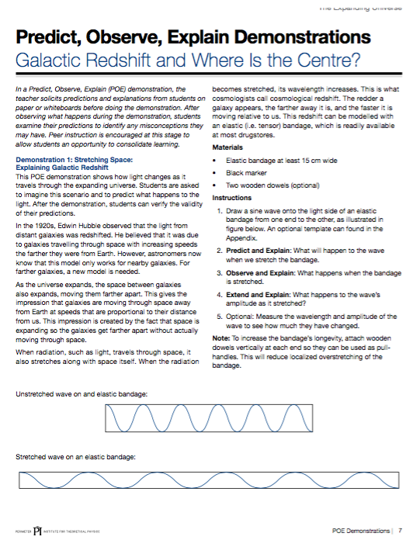

Activity 3  
The Expansion of Space

*This activity is designed to help students understand the nature of our expanding universe, and how galaxies that are farther from us appear to be moving faster than galaxies that are nearby.*

Materials

* different-sized washers or paper clips (set of 10 per group)
* elastic bands of identical thickness and different lengths (minimum of 9 per group)
* ruler

Procedure

Part 1: Measurements

1. Create a “chain of galaxies” by attaching each galaxy—a washer or a paper clip—to elastic bands. Be sure to use different sizes of washers or paper clips and to vary the distances between the galaxies by using a variety of lengths of elastic bands. Loop the elastics around themselves when attaching them to the washers or paper clips.



1. Each group will determine the distance between galaxies using a different measurement unit, for example, centimetres, metres, floor tiles, inches, feet, or hand lengths.  
   Unit Choice: ____________________________________________
2. In a large space, such as a hallway, place your galaxy chain on the floor, leaving it unstretched.
3. Choose your group’s home galaxy from your chain, and record in Table 1. Measure the distance from your home galaxy to the other galaxies in your chain. Record your measurements in column 1 of Table 1.

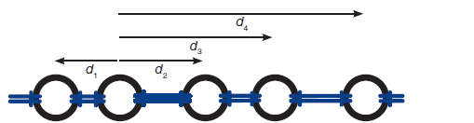

Measure the distances (d1, d2, d3, d4 etc.) from your home galaxy to all the other galaxies.

1. Now the universe needs to expand. A group member is positioned at each end of the galaxy chain, then they each pull their washers such that the universe doubles in size (from end to end). A third group member repeats Step 4 and measures the new distances to the galactic neighbours. Record your measurements in column 2 of Table 1.

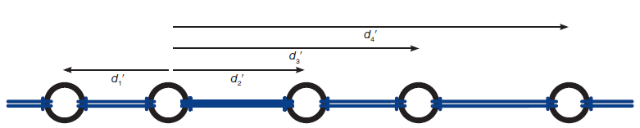

Measure the stretched distances (d1′, d2′, d3′, d4′ etc.) from your home galaxy to all the other galaxies.

**Part 2: Plotting and Comparison**

1. Complete column 3 of Table 1 by calculating the increase in distance between the two measurements in columns 1 and 2.

Table 1 Galaxy Distance Measurements

|  |  |  |  |
| --- | --- | --- | --- |
| **Home Galaxy Number: ____** | **Column 1: Original Distance (unit)** | **Column 2: New Distances (unit)** | **Column 3: Increase in Distances (unit)** |
| **Galaxy ___________** |  |  |  |
| **Galaxy ___________** |  |  |  |
| **Galaxy ___________** |  |  |  |
| **Galaxy ___________** |  |  |  |
| **Galaxy ___________** |  |  |  |
| **Galaxy ___________** |  |  |  |
| **Galaxy ___________** |  |  |  |
| **Galaxy ___________** |  |  |  |
| **Galaxy ___________** |  |  |  |

1. Graph the data from Table 1, with the original distance (column 1) on the horizontal axis and the increase in distance (column 3) on the vertical axis. Be sure to label both axes and include your chosen measurement units.  
   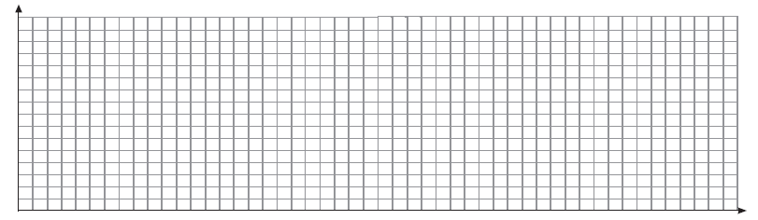
2. Draw a line of best fit, and calculate the slope. Be sure to include all units.

**Inquiry**

(Answer on a separate piece of paper.)

1. Compare your slope with that of your classmates. What do you notice? What effect does your choice of home galaxy have on the slope?
2. Describe how the positions of the distant galaxies changed compared to the positions of the nearby galaxies. How does your slope reflect this?
3. How would the chain look if the slope value were higher? Lower? How would you describe the universe if the slope were higher? Lower?
4. Comment on the difference in measurement units used. Is one system better than another?
5. If the universe is expanding, why don’t the sizes of the galaxies expand as well?

Activity 4

Why is the Sky Dark at Night?

Part 1: Exploring Brightness and Luminosity

Why is the sky dark at night? The sky is dark at night because the Sun is not up in the sky at night. However, this is only part of the answer. A more complete answer requires an understanding of the nature of light, as well as an understanding of the origin and evolution of the universe.

1. What other luminous (light producing) objects other than the Sun are in space?
2. Light gets fainter as it moves farther away. Why? We can model this phenomenon with a balloon. Your teacher will give you an uninflated balloon with a circle of dots drawn on it. You can think of the dots as rays of light striking the balloon from inside the balloon.   
   (a) Predict how the circle of dots will change when the balloon is inflated. Explain your answer.

(b) Observe what happens as the balloon is inflated. Explain any differences from your prediction.

1. A flashlight is pointed at the floor, forming a spot of light.  
   (a) Predict how the spot will change when the flashlight is moved farther from the floor. Explain your answer.

(b) Observe what happens. Explain any differences from your prediction.

1. A flashlight is pointed at the floor, forming a spot of light. The radius of the spot of light is measured and its area is calculated. The brightness of the spot is measured. Then the flashlight is moved so it is twice as far from the floor.
2. The new radius will be _____ times the old radius. Explain your answer with a diagram.  
   A. ¼  
   B. ½  
   C. 2  
   D. 4
3. The new area will be _____ times the old area. Explain your answer with a diagram and the equation for the area of a circle, *A* = *πr*2.  
   A. ¼  
   B. ½  
   C. 2  
   D. 4
4. The new brightness will be _____ times the old brightness. Explain by referring to the balloon.  
   A. ¼  
   B. ½  
   C. 2  
   D. 4

5. Two flashlights are pointing at the ceiling, each forming a spot of light. The spot from flashlight 1 is brighter than the spot from flashlight 2. This is because flashlight 1 is  
A. closer to the ceiling.  
B. farther away from the ceiling.  
C. more luminous.  
D. closer and/or more luminous.

6. What is the difference between brightness and luminosity? Use the flashlights as an example.

7. Figure 1 shows the seven similarly bright stars of the Big Dipper. They look equally close but they are not. For example, star A is two times farther away from us than star B. How would you arrange seven students with different flashlights to form something that looks like the Big Dipper?

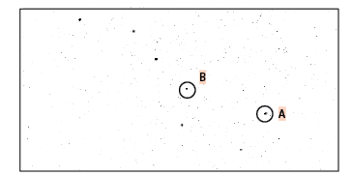

Figure 1 Diagram of stars in the Big Dipper

8. Figure 2 shows a close-up of some of the stars in the Andromeda Galaxy.

(a) The Andromeda Galaxy is 300 light years across and 2.5 x 106 light years from Earth. In a scale diagram, Andromeda is represented by a 3 mm dot. How far away would the Earth be placed?

(b) Star D is much brighter than star C. Is star D more luminous than C, or is it closer? Explain.

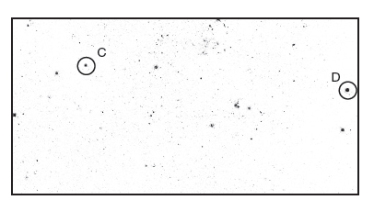

Figure 2 Stars in Andromeda

9. Figure 3 shows part of the Hubble Deep Field image, which shows some of the most distant objects ever found. It also sometimes shows nearby stars. Can you tell which object, E or F, is more luminous? Explain.

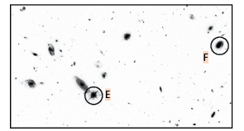 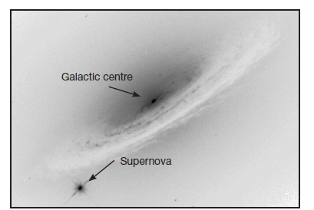

Figure 3 A portion of the Hubble Deep Field image Figure 4 Galaxy NGC 4526 and a supernova

10. Figure 4 is a photograph of galaxy NGC 4526, which contains hundreds of millions of stars. Near its outer edge there is a single star, which is a supernova.

(a) The supernova and the galaxy are the same distance away. Which is true?  
A. The supernova is as bright as the galaxy centre.  
B. The supernova is as luminous as the galaxy centre.  
C. The supernova is as bright and as luminous as the galaxy centre.

(b) A star can only emit these huge amounts of energy for a short time. Astronomers on Earth see these supernovas brighten and then grow dim. The time taken to brighten and dim can be used to calculate the supernova’s luminosity. An object whose luminosity is known is called a standard candle. When an object’s luminosity is combined with its brightness, we can calculate  
A. how hot the object is.  
B. how old the object is.  
C. how fast the object is moving.  
D. how far away the object is.

Part 2: Exploring the Evolution of the Universe

11. Watch the *Alice & Bob* animation "Why Is It Dark at Night?" at <https://www.youtube.com/watch?v=iKTv-BDZ8Os>.

(a) Alice thinks that there should be a star in every direction that you look. Let's build a model to illustrate her idea. Take a whiteboard or a piece of paper and draw many dots in random places to represent stars. Draw Earth as a circle near the centre. Draw a line from Earth in a direction that stops at a nearby star. Draw another line that stops at a distant star and another that does not stop at a star. Would there be a star in every direction if the universe were finite? Explain using the whiteboard or paper model.

(b) Suppose that there is a star in every direction. Alice says that this should make the whole sky look as bright as the Sun. To understand why, look at Figure 5, which shows a simplified view of stars in three different directions. Which direction would look the brightest, or will they all be the same? Explain.

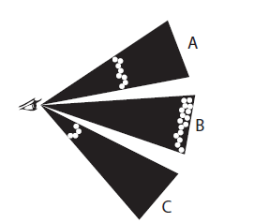

Figure 5 Observing stars in three different directions, A, B, and C

(c) Bob suggests that maybe the light from the stars hasn’t reached us yet. Draw a diagram that shows how this is possible.

12. Watch the Minute Physics video “Why is it dark at Night?” at <https://www.youtube.com/watch?v=gxJ4M7tyLRE>

13. The night sky is dark. It is not bright in all directions. Which of the following best explains why? Explain using a diagram and words.

(a) The stars did not always exist.  
(b) The universe didn’t always exist.  
(c) The universe is not infinitely big.  
(d) Either A, B, or C is possible.